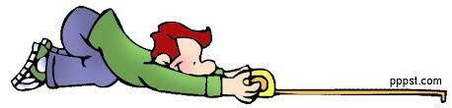 Metric Measurement Lab – Regulars IPC
Instructions: For this lab, you will visit several different stations to measure items using various lab equipment.
Graduated cylinders – what volume of liquid is in each one?
What metric units are you using at this station? _______________

A. _________________ B. _________________ C. _________________

Meter Sticks & Rulers – measure the lengths of each object using a meter stick or ruler.
What metric units should you be using at this station? Circle the ones that make sense: m in cm

A. styrofoam block _________________

B. height of our classroom door _________________

C. length of the hallway from one end to the other _____________________

D. length of lab table top (in the back) ________________ E. width of lab table top ________________

What is the area of the lab table’s top? __________________
What additional measurement would you need in order to find its volume? ____________________

Triple Beam Balance – measure the mass of each cube.
What metric units should you use at this station? ________________

A. _________________ B. _________________

Water displacement – use your water displacement skills to find the volume of the marble. USE UNITS!!
Volume of water before adding object: _________________
Volume of water after adding object: __________________
Volume of object: _______________________

