NOTES: Designing An Experiment – How to Make IVCDV Charts

A ______________________ is something that changes
There are ________ concepts that go into making a good experimental design. They are:

An __________________ ____________________ is the variable that is ________________ ______ _______________ by the experimentor (scientist).
It is also known as: ___________________, stimulus, reason, _______________________ _____________________, etc.
It is the “_________” part of a hypothesis.

A ___________________ ____________________ is the variable that ____________________ to the changes made by the experimentor.
It is also known as: _________________, ________________, ___________________ ____________________, etc.
It is the “_____________” part of a hypothesis.

Constants are:

Control Group is:

Experimental Group is:

Each experimental group has only ________ factor different from the other test groups: it is the independent variable.
Experiments are always repeated because:

Once a scientist descides what to test, he/she must determine HOW to manage everything else. The IVCDV chart is a useful way to organize and design an experiment. For example, say a scientist wants to experiment on how different amounts of fertilizer affect the growth of plants.

Look at the chart below. IV stands for __________________ ____________________. Notice that the number of fertilizer drops is changing because the scientist is purposely doing so. The amount of fertilizer is the manipulated variable in the experiment.
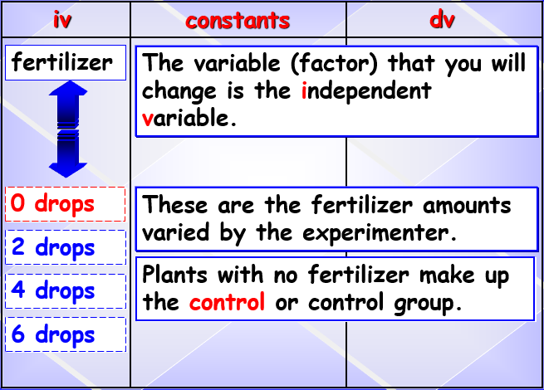
Look at the chart below. DV stands for ____________________ ____________________. Notice that the plant growth is changing because of the different amount of fertilizer. The plant growth is the responding variable in the experiment because it is responding to the changing fertilizer amounts.
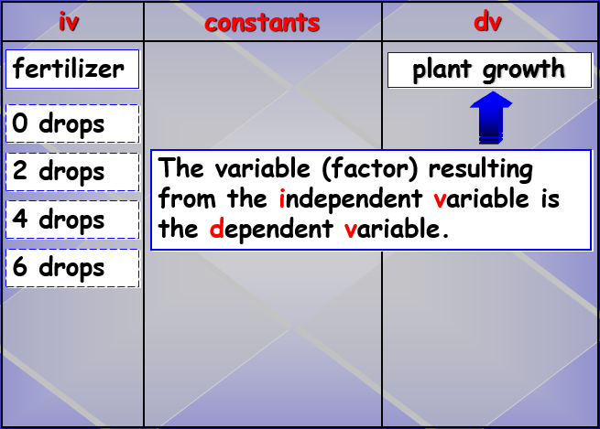
Look at the chart below. C stands for _____________________. Notice that all other aspects of the experiment except the amount of fertilizer are held constant, or the same, for each plant tested. In other words, no matter how much fertilizer a plant gets, all plants receive the same amount of water, same type and amount of soil, each plant is the same, etc. In this way, we can be SURE that the only thing affecting the different plant growths is the amount of fertilizer. If we gave each plant a different amount of water too, then we could not say for sure whether the change in growth was due to the amount of fertilizer or the amount of water.
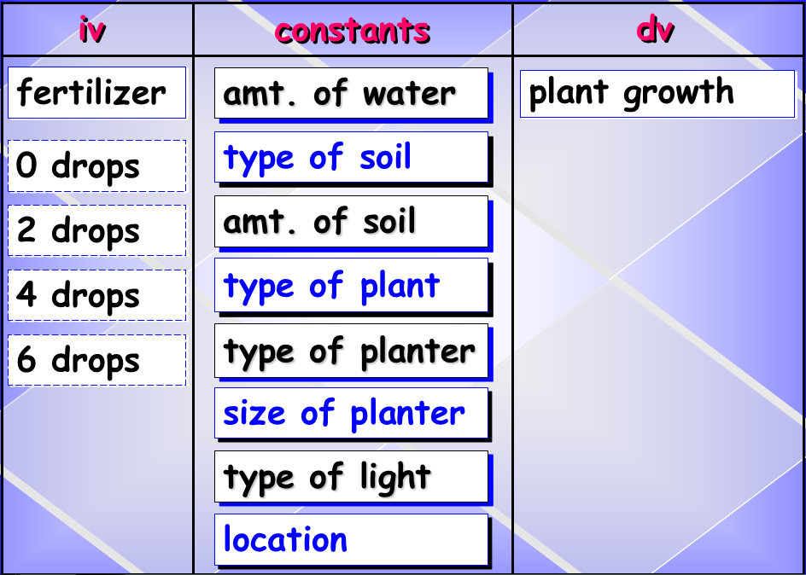

Look at the chart below. Notice that the plant with no fertilizer is the _________________ group, and the plants with fertilizer added make up the _____________________ group. The control group is the standard to which you compare all the tested groups’ growth.
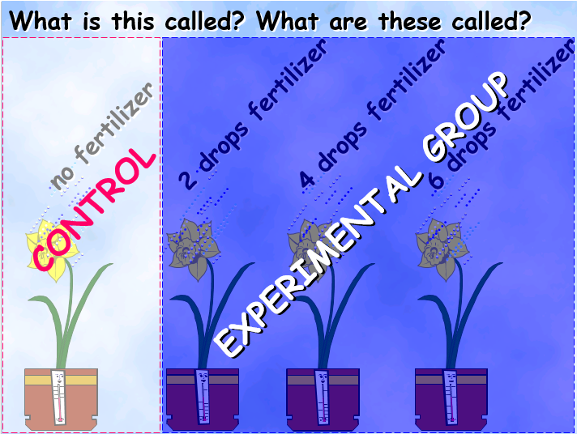
Look at the picture below. Notice that plant type, pot size, water amount, temperature, exposure to sunlight, etc are all called ______________________ because they are held the same for every plant. These are held constant so that we are SURE that it’s the fertilizer
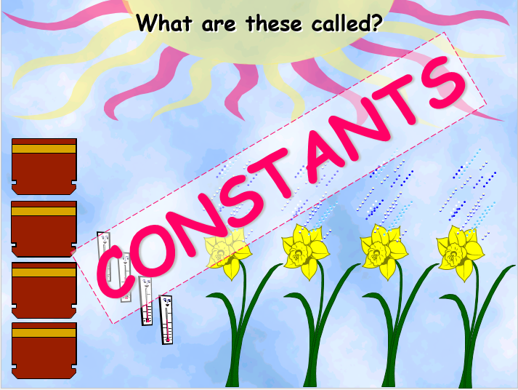
Look at the picture below. It represents the __________________ ____________________, which can be stated in a variety of ways: the results of, the response to, or the effects of adding fertilizer.
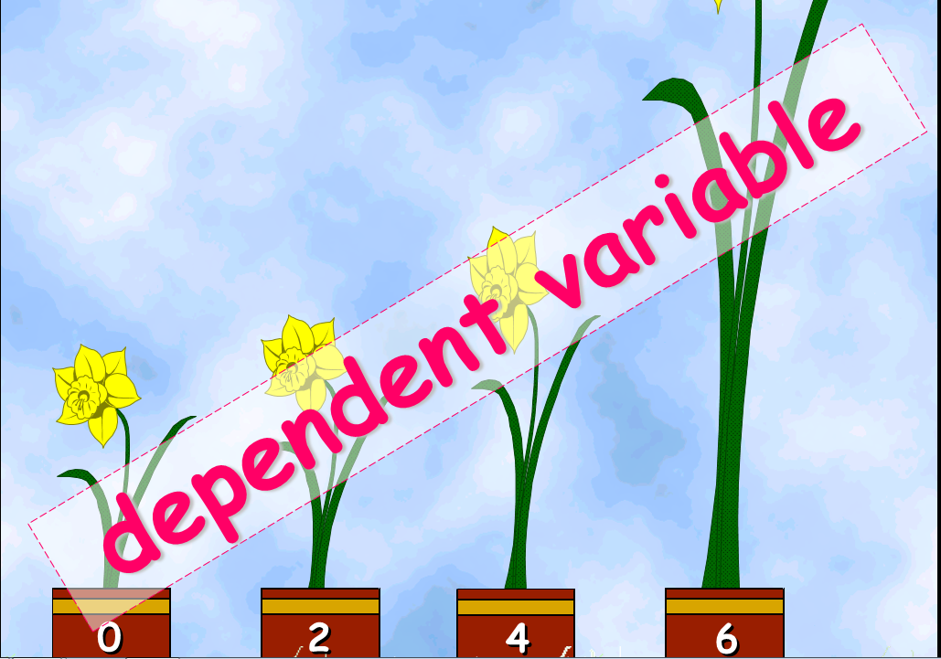
Design an experiment using the IVCDV chart to test the effectiveness of various sunscreen SPFs on aliens.
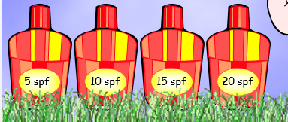
IV (independent variable) | C (constants) | DV (dependent variable)

NOTES: Designing An Experiment – How to Write a Hypothesis, Make a Data Table

Writing a Hypothesis
A hypothesis is written in a basic ______/_________ format.
Examples:
If a person doesn’t brush their teeth regularly, then tooth decay or gum disease will occur.
If a racecar driver uses higher octane fuel, they will have better engine efficiency.

The IVCDV charts that we learned how to make last class can be helpful to you in making a hypothesis.
Look at the chart below. See that the _______________________ ______________________ makes up the “_____” portion of the hypothesis.
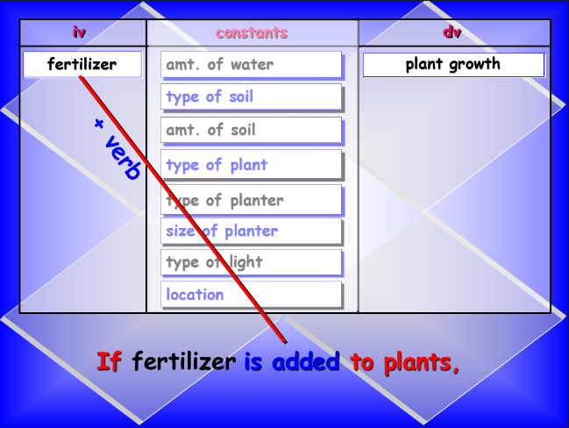

Look at the chart below. See that the ______________________ _______________________ makes up the “________” portion of the hypothesis.
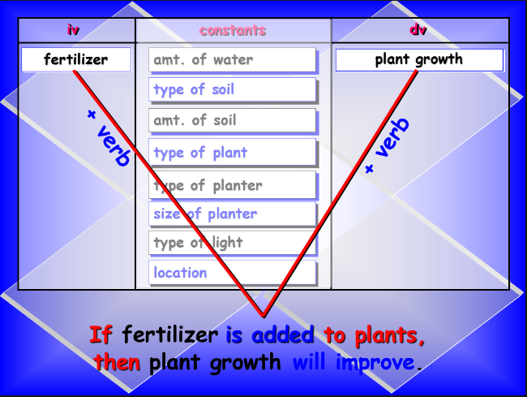
So we write our hypothesis in this format:
_________ _____________________ ____________________ + _____________,
__________ ________________________ _________________________ + _____________.
Try to write a hypothesis for the alien example from last class (the one you did with a partner). Use the IVCDV chart below as a reminder of what you did. Write your new hypothesis in the open box below.
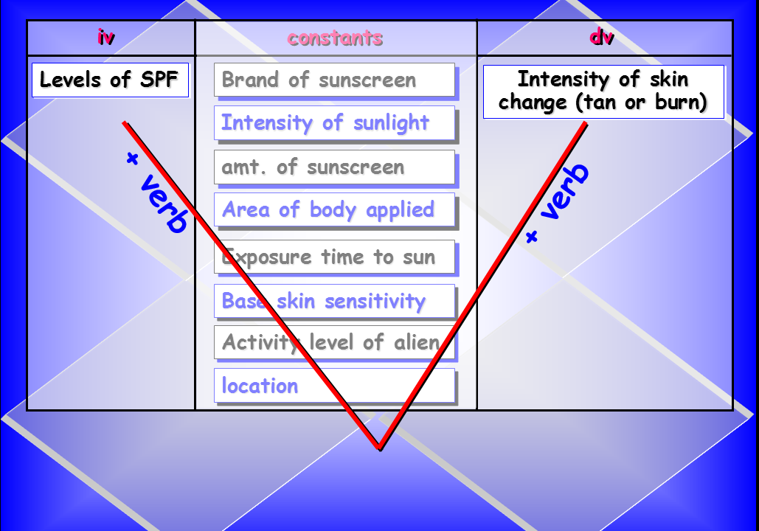
Hypothesis:

Creating a Data Table
A data table has at least ____________ columns of information.

The ____________ column holds the information about the ____________________ ___________________, and is filled out _________________ the experiment begins.

The ____________ column holds the information about the ____________________ ___________________, and is filled out ___________________ the experiment.

See the charts below as an example:
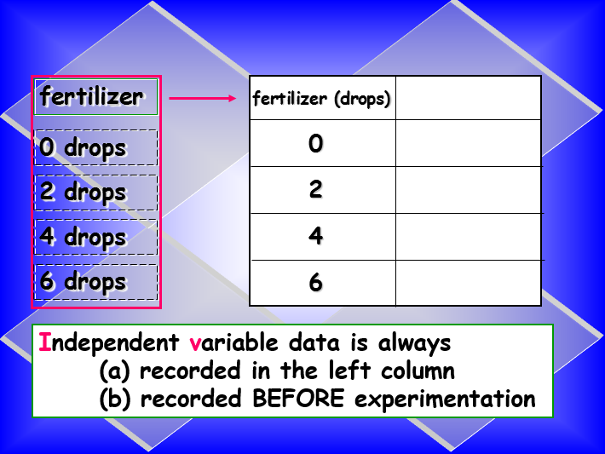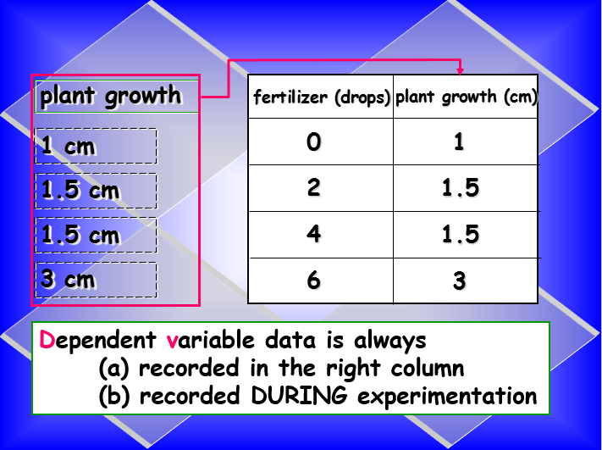

Lastly, you want to choose an appropriate title that accurately tells the reader what your data is all about. For the fertilzer/plant experiment it might look something like this:
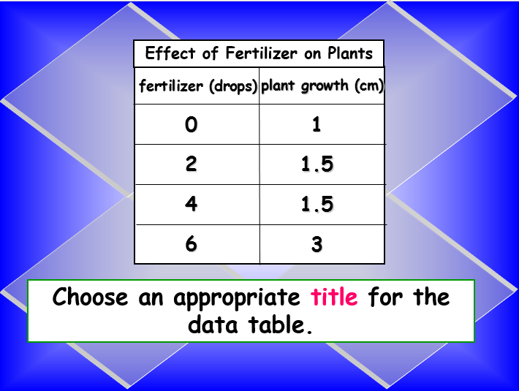

What might be an appropriate title for the alien/sunscreen data table? Write your idea below:

